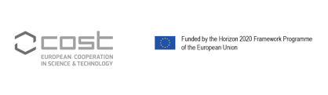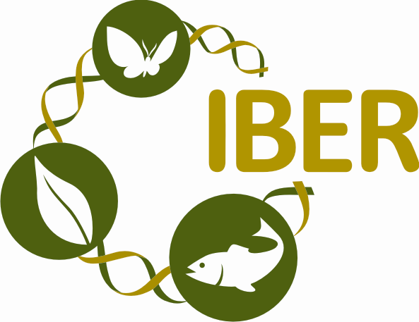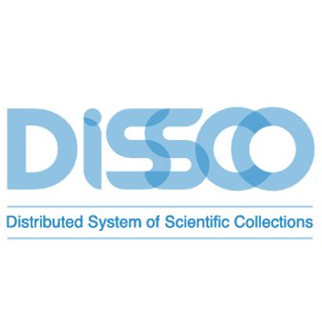

HOME

The First Training School on Digitization and Data Management of Collections!

MOBILISE COST Action: “Mobilising Data, Policies and Experts in Scientific Collections”, in cooperation with GBIF https://www.gbif.org and DISSCo https://dissco.eu/, organises its first Training School (TS) in “Digitisation and data management challenges in small collections”.

This hands-on and interactive training initiative will give the opportunity to Natural History Institutions holding small collections to get informed and exercised on the digitisation and management of their biological and geological collections in order to be able to develop their own Institutional Digitisation Strategy & Plan.

This two-days TS will be held in Sofia, Bulgaria, on 14th and 15th of March, 2019, hosted by the Institute of Biodiversity and Ecosystem Research and the National Museum of Natural History – Sofia, both units of the Bulgarian Academy of Sciences. Deadline for applications is the 10th of February 2019. Applicants need to register in this link https://form.jotformeu.com/90222819863360 and upload, in the same link, a short CV of one page. Selected trainees will be duly informed individually. They will receive a COST Trainee Grant for their stay and travel costs. More information here.

COST
COST is an intergovernmental framework for European Cooperation in Science and Technology established to initiate networking and coordination of nationally funded research activities on a European level. It was established in 1971 by 19 member countries and currently includes 35 member countries across Europe, and Israel as a cooperating state. It facilitates bringing scientists together under light strategic guidance based on networks, called COST Actions, centred on research projects in fields that are of interest both to COST countries and cooperating countries.
OVERVIEW AND TIME SCHEDULE
The Training School (TS) “Digitisation and data management challenges in small collections” will target a basic but important part of the digitisation process of biological and geological collections. Origins of data (taxonomic data, specimens and materials, literature data, field work notes, occurrence data, remote sensing data, etc.) will be the first topic addressed. Then it will tackle the data quality issue, for ensuring the maximum quality when digitising taxonomic, geographical, collection and descriptive data. Finally, the TS will focus in data cleaning in order to improve the quality of data and make them “fit-for-use” by defining and determining error types, search and identify error instances, correct the errors, document error instances and error types and modify data entry procedures to reduce future errors.
The TS will be a hands-on experience, since, according to its schedule, most of the time is dedicated to exercises on data quality and cleaning while group work will ensure and motivate interaction between trainees and trainers and foster lively discussions. Moreover, trainees will have the possibility to bring sample(s) of their institutional biodiversity and geodiversity digital database and exercise on them.
WHO CAN APPLY
The Training School “Digitisation and data management challenges in small collections” is addressed to everyone who is engaged in biological and geological collections and their data, such as Curators and Collections’ managers, Directors/Senior managers, Collections’ Digitization managers/officers, Scientists on bio- or geo informatics, Early Career Investigators (individuals who are within a time span of up to 8 years from the date they obtained their PhD/doctorate in full-time equivalent), Students (Post graduates, MSc, PhD), Technicians of collections. They must be engaged in an official research programme, or employed by, or affiliated to, an institution, organisation or legal entity, which has within its remit a clear association with performing research.

According to COST Vademecum (https://www.cost.eu/wpcontent/uploads/2018/10/20180501-Vademecum2.pdf) trainees who are eligible to be reimbursed are:

- Trainees from COST Full Members / COST Cooperating Member.
- Trainees from Approved NNC Institutions.
- Trainees from Approved European RTD Organisations.

Trainees not eligible to be reimbursed are:

- Trainees from COST Partner Members.
- Trainees from Approved IPC Institutions.
- Trainees from Approved IO, EU Commission, Bodies, Offices and Agencies.
- Other Trainees not specifically mentioned as being eligible.

APPLICATION DEADLINE AND GRANTS
Application deadline for the Training School is 10 February 2019. Applicants need to register in the link https://form.jotformeu.com/90222819863360 and upload, in the same link, a short CV of one page. The Training School is limited to 30 trainees. No fees apply to the Training School.
Successful applicants will be notified by February 17th, 2019 and will receive a fixed COST Grant (Trainee Grant) amounting to 600 Euros, immediately after the Training School. Trainee Grants do not necessarily cover all expenses related to attending the Training School. The Trainee Grant is a contribution to the overall travel, accommodation and meal expenses of the grantee. The amount allocated for accommodation and meal expenses cannot exceed EUR 160 per day.

Each successful applicant, immediately after February 17th 2019, must register for an e-COST profile at https://e-services.cost.eu - and must add his/her bank details to his/her e-COST profile in order to receive, afterwards, his/her e-COST invitation to attend the Training School.

COST policies on gender balance, involvement of Early Career Investigators, and geographical inclusiveness will be followed.
LEARNING OUTCOMES

By the end of this TS, trainees will have the knowledge, skills and competences in order to:

- Specify origins of data in their institutional digital databases
- Ensure the maximum quality when digitising taxonomic, geographical, collection and descriptive data
- Improve the quality of data
- Define and determine error types
- Search and identify error instances
- Correct the errors
- Document error instances and error types
- Modify data entry procedures to reduce future errors

CERTIFICATE

At the end of the TS, trainees will obtain the MOBILISE COST Action Certificate with ECVET (European Credit system for Vocational Education and Training) points.

LANGUAGE REQUIREMENTS
In order to follow the TS, trainees need a CEFR (Common European Framework of Reference for Languages) B1 level of English, as the formal language of the TS is English.
TECHNOLOGY AND OTHER REQUIREMENTS
Trainees are required to bring their own laptops. They are also recommended to bring sample(s) of their institutional biodiversity and geodiversity digital database in order to be exercised on them.

PROGRAMME

MOBILISE COST Action 17106
Training School: “Digitisation and data management challenges in small collections”
Sofia, Bulgaria, 14-15 March 2019

Venue: Bulgarian Academy of Sciences – Research Campus 1 – Institute of Mechanics,
Acad. G. Bonchev Street, Block 4, 1113 Sofia, Bulgaria

Day 1 14/03/2019 | SESSION A | 8:30 - 9:00 | Welcome and Introduction
 |  | 9:00-10:00 | Developing Institutional Digitisation Strategy & Plans-Examples-Role Play
 |  | 10:00-10:30 | Origins of data-Examples
 |  | 10:30-11:00 | Coffee
 | SESSION B | 11:00- 11:40 | Data Quality and Data Cleaning
 |  | 11:40-12:00 | Open Refine
 |  | 12:00- 12:20 | Other Management Tools
 |  | 12:20-12:40 | Publishing of data, Image and Data capture
 |  | 12:40-13:00 | Discussion
 |  | 13:00-14:00 | Lunch
 | SESSION C | 14:00-15:00 | Exercises on Data Quality & Cleaning
 |  | 15:00-15:30 | Coffee
 |  | 15:30-17:00 | Exercises on Data Quality & Cleaning
Day 2 15/03/2019 | SESSION A | 8:30-10:30 | Exercises on Open Refine & Other Management tools
 |  | 10:30-11:00 | Coffee
 | SESSION B | 11:00-12:30 | Exercises on Open Refine & Other Management tools
 |  | 12:30-13:30 | Lunch
 | SESSION C | 13:30-14:30 | Digitisation Strategy & Plans-Examples, Q&A, Issues solving
 |  | 14:30-15:00 | Final discussion. Evaluation
LOGISTICS

Venue

Management Committee and All hands meeting (12-13 March 2019), Bulgarian Academy of Sciences – Campus 1, Hotel of Bulgarian Academy of Sciences (HBAS) and Institute of Mechanics (IM) (Block 4). Meeting rooms are in both buildings (at 200 m from one another).

Registration desk, lunch on 12 and 13 March and cocktail (dinner) on 12 March at HBAS

Training school (14-15 March 2019), Bulgarian Academy of Sciences – Campus 1, Institute of Mechanics (IM) (Block 4)

Transport

● By plane

All relevant information arriving in Sofia by plane can be found at Sofia Airport.

Sofia Airport is located about 10 km east of the city centre. The airport has two terminals (Terminal 1 and Terminal 2). Regular airlines make their flights to Terminal 2, and Terminal 1 is mainly used for low-cost and charter flights.

From Sofia Airport to Sofia City (and vice versa) you can easily get around by taxi, busses or metro.

By taxi:

Taxi from the airport to the centre of Sofia costs about 8-10 Leva (BGN) [4-5€]. We strongly recommend to use only the licensed taxi company for airport services OK SUPERTRANS. The taxi stop is located adjacent to Terminal 2, west to it (but not in front of it, where frequently fake taxi cars appear working at the rate much higher than that of the licensed company).

By bus:

Busses Nos. 84 and 184 travel from Sofia Airport to the city centre (Sofia University). Buses run at intervals of 15-30 min depending on the time and day. The price of a single ticket is 1.60 Leva (BGN) [= 0.8€], and the trip in one direction continues about 25 minutes. According to the city transport regulations, if you have a suitcase or bag bigger than 40 x 40 x 60 cm, you need to have a second ticket at the same price as for a passenger. The tickets are purchased on the stops, before getting on the bus.

The name of the nearest bus stop for the venue of our event is “Hotel Pliska” for both lines.

By Metro:

You can use to run from and to the airport Line 1 of the Sofia Metro. The stop is in the eastern part of Terminal 2 and you can easily reach it by following the blue line on the floor in the public area of the terminal. The subway line allows connection to the city centre, central bus station and central railway station in less than 30 minutes. Trains run from 5:30 to 24:00.

The name of the nearest metro station for the venue of our event is “Joliot-Curie”. Get out the subway, go along Joliot Curie Street to the north and cross Tsarigradsko shosse Boulevard. The Institute of Mechanics is situated on Acad. G. Bonchev Street, block 4.

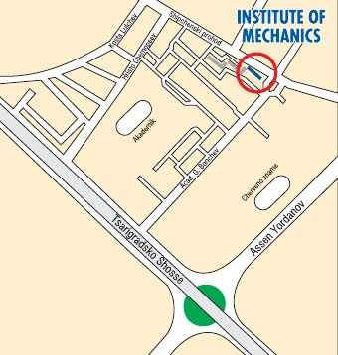

● By train or bus

The central bus station is adjacent to the central railway station. For the area of the event, you can travel by the licensed taxi company for airport services OK SUPERTRANS, or take busses Nos. 213 or 305 to “Hotel Pliska” bus stop (some 30 min).

More information about Sofia can be found at the Sofia Municipality official webpage and Welcome in Sofia.

Accommodation

There are numerous accommodation possibilities in Sofia. We suggest choosing some situated at a walking distance from the venue of the events:

Hotel of Bulgarian Academy of Sciences
50 Shipchenski Prohod Street, 1113 Sofia
https://www.booking.com/hotel/bg/dom-na-ucheniya-ban.en-gb.html
Situated in Campus 1 of Bulgarian Academy of Sciences. The program of the meeting is partly based on the facilities of this hotel: workshops, lunch breaks and cocktail. The registration desk will be also organised in this hotel. The main conference hall (Institute of Mechanics) is at 200 m from it.
Hotel Kibella
26, Alexander von Humboldt Street, 1113 Sofia
http://www.hotelkibella.com/
At walking distance from the venue (15 min).
Hotel Rotasar
Liditze Street and Kosta Lulchev Street, 1113 Sofia
http://www.rotasar.com/
At walking distance from the venue (15 min).
Hotel Rai
6 Akademik Nikola Obreshkov Street, 1113 Sofia
www.hotel-rai.com
At walking distance from the venue (10 min).
Best Western Europe Hotel
https://www.visitbulgaria.net/en/sofia/hotels/best_western_europe_hotel.html
1 Liditze Street, 1113 Sofia
At walking distance from the venue (15 min). More luxury and more expensive option than those mentioned above it.
Park Hotel Moskva
25 Nezabravka Street, 1113 Sofia
https://www.parkhotelmoskva.net/?lang=en
At walking distance from the venue (30 min). The most luxury option in the neighbourhood. Close to the Joliot-Curie Metro Station (direct connection to the Sofia Airport).

