MOBILISE COST Action 17106
Blended Training School:
“Next step in the digitization process of Natural History collections:
Publishing of biological, geological, palaeontological & mineralogical data”

ONLINE PART (via zoom)
20 January 2023 13.00 -17.00 PM CET

Join Zoom Meeting
20/01/2023 | SESSION A | 13.00 – 13.15 | WELCOME, GETTING TO KNOW EACH OTHER, EXPECTATIONS, PRESENTATION OF THE AGENDA  Catherina Voreadou, Iasmi Stathi
 |  | 13.15 – 13.45 | DATA QUALITY & CLEANING, PREPARATION OF DATA SETS - QUESTIONS  Dimitri Brosens
 |  | 13.45– 14.15 | GUIDELINES FOR DATA CLEANING  Heimo Rainer
 |  | 14.15 – 14.45 | INTRODUCTION TO BIODIVERSITY DATA STANDARDS  Larissa Smirnova
 |  | 14.45-15.00 | Brake
 | SESSION B | 15.00-15.30 | GBIF, IPT (INTEGRATED PUBLISHING TOOLKIT), TYPES OF DATA SET CONVENIENT FOR PUBLICATION IN GBIF  Piotr Tykarski
 |  | 15.30-16.00 | GeoCASe - ABCDEFG STANDARTS (ACCESS TO BIOLOGICAL COLLECTION DATABASES EXTENDED FOR GEOSCIENCES), TYPE OF DATA SETS CONVENIENT FOR PUBLICATION IN GeoCASe  Heimo Rainer
 |  | 16.00-17.00 | Discussion with participants: Description of datasets that the participants should bring with them  All
FACE TO FACE PART
06-07 February 2023
Venue: Brussels, Belgium

IMPORTANT INFO:
ALL HANDS-ON EXERCISES IN THE DAILY PROGRAM WILL BE IMPLEMENTED IN PARALLEL GROUPS:

- Trainees managing Biological data
- Trainees managing Geological, Palaeontological, Mineralogical data

DAY 1:  06/02/2023 | SESSION C | 09.00 – 09.15 | WELCOME, PRESENTATION OF THE AGENDA  Catherina Voreadou
 |  | 09.15 – 10.30 | HANDS ON EXERCISE in parallel groups:  CHECKING OF THE CLEANING AND VALIDATION OF DATA IN ORDER TO BE READY TO BE PUBLISHED  Dimitri Brosens, Heimo Rainer, Piotr Tykarski, Larissa Smirnova
 |  | 10.30 - 11.00 | Coffee
 | SESSION D | 11.00 – 12.00 | HANDS ON EXERCISE in parallel groups:  CHECKING OF THE CLEANING AND VALIDATION OF DATA IN ORDER TO BE READY TO BE PUBLISHED  Dimitri Brosens, Heimo Rainer, Piotr Tykarski, Larissa Smirnova
 |  | 12.00-13.00 | Lunch
 | SESSION E | 13.00-15.00 | HANDS ON EXERCISE in parallel groups:  PUBLISHING OF BIOLOGICAL DATA IN GBIF- PUBLISHING OF GEOLOGICAL, PALAEONTOLOGICAL, MINERALOGICAL DATA IN GeoCASe  Dimitri Brosens, Heimo Rainer, Piotr Tykarski, Larissa Smirnova
 |  | 15.00-15.30 | Coffee
 | SESSION F | 15.30-17.00 | HANDS ON EXERCISE in parallel groups:  PUBLISHING OF BIOLOGICAL DATA IN GBIF- PUBLISHING OF GEOLOGICAL, PALAEONTOLOGICAL, MINERALOGICAL DATA IN GeoCASe  Dimitri Brosens, Heimo Rainer, Piotr Tykarski, Larissa Smirnova
 |  | 19.00 | Dinner
DAY 2:  07/02/2023 | SESSION G | 09.00 – 10.30 | HANDS ON EXERCISE in parallel groups:  PUBLISHING OF BIOLOGICAL DATA IN GBIF- PUBLISHING OF GEOLOGICAL, PALAEONTOLOGICAL, MINERALOGICAL DATA IN GeoCASe  Dimitri Brosens, Heimo Rainer, Piotr Tykarski, Larissa Smirnova
 |  | 10:30 – 11.00 | Coffee
 | SESSION H | 11.00 - 11.45 | HANDS ON EXERCISE in parallel groups:  PUBLISHING OF BIOLOGICAL DATA IN GBIF- PUBLISHING OF GEOLOGICAL, PALAEONTOLOGICAL, MINERALOGICAL DATA IN GeoCASe  Dimitri Brosens, Heimo Rainer, Piotr Tykarski, Larissa Smirnova
 |  | 11.45 – 12.00 | EVALUATION, CERTIFICATES
 |  | 12.00 - 13:00 | Lunch

TRAINERS SHORT CVs

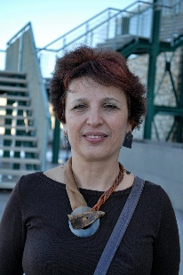 | Dr Catherina Voreadou is the head of Hydrobiology Lab of the Natural History Museum of the University of Crete. In parallel, since 1998 she is the head of Education and since 2012 she is leading also the Centre of Environmental Training of NHMC responsible for Life Long Learning. Member of the Greek National Accreditation Centre for Continuing Vocational Training (EKEPIS), as trainer for adults. She has coordinated or participated in 19 Research Educational and Training projects funded either by National or European sources. She is the author and editor of many Educational editions.
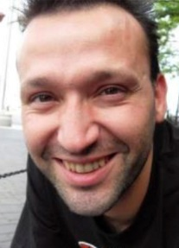 | Dimitri Brosens, MSc, is the Biodiversity Data Liaison Manager from the Belgian Biodiversity Platform in the Flemish Research Institute for Nature and Forest since early 2009. The ultimate goal of Dimitri is to get Belgium on the world map of biodiversity data. He has a particular interest in the publication, standardization and interoperability of biodiversity datasets.
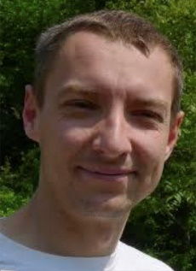 | Dr Piotr Tykarski works at the University of Warsaw, teaching entomology, invertebrate zoology, ecology and GIS. His scientific interests focus on saproxylic beetles and, factors and patterns in biodiversity. He has been involved in biodiversity informatics activities and GBIF in Poland since 2003. Currently in this respect he plays a double role of a node manager and a HoD of GBIF for Poland.
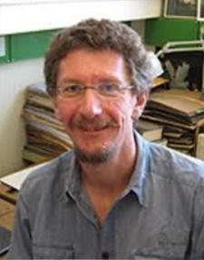 | Dr Heimo Rainer is a curator in the Viennese Herbaria of the NHM (W) and the University (WU) and coordinates digitization there. They have established the Virtual Herbaria Platform JACQ a consortium of 40+ institutions and individuals. His research focus is the taxonomy of a tropical plant genus Annona.
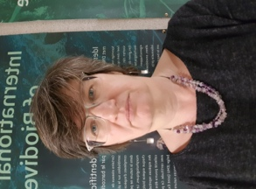 | Dr Larissa Smirnova is assistant at Royal Museum for Central Africa where she currently coordinates Synthesys+ project. Since 2009 she has been involved in different European and national projects connected to biodiversity informatics and digitization. She is also part of the GBIF mentoring and training program and has participated as invited coach in a number of training courses on data publishing.

